SE 461 Project Report

Morgan Buell and Emaan Bashir

For this project, we used three examples to explain how we developed our JUnit test cases and satisfied the coverage criterion for each of our cases. We made CFG’s for three different methods from the SnakeGame.Java file, these being snakeGame(), startGame(), and updateSnake(). We will be showing our CFG’s for each of these three as well as our Test Results, our Test Paths, and the coverage types.

**snakeGame() Edge-Pair Coverage:**

TR = {[1, 2, 3], [2, 3, 4], [2, 3, 5], [3, 4, 38], [3, 5, 4], [3, 5, 6], [5, 4, 38], [5, 6, 7], [5, 6, 4], [6, 7, 4], [6, 4, 38], [7, 4, 38], [1, 8, 9], [8, 9, 10], [8, 9, 11], [9, 10, 38], [9, 11, 10], [9, 11, 12], [11, 10, 38], [11, 12, 13], [11, 12, 10], [12, 13, 10], [12, 10, 38], [13, 10, 38], [1, 14, 15], [14, 15, 16], [14, 15, 17], [15, 16, 38], [15, 17, 18], [15, 17, 16], [17, 16, 38], [17, 18, 16], [17, 18, 19], [18, 19, 16], [18, 16, 38], [19, 16, 38], [1, 20, 22], [20, 22, 23], [20, 22, 24], [22, 23, 38], [22, 24, 23], [22, 24, 25], [24, 23, 38], [24, 25, 26], [24, 25, 23], [25, 26, 23], [25, 23, 38], [26, 23, 38], [1, 27, 29], [27, 29, 28], [27, 29, 30], [29, 28, 38], [29, 30, 28], [30, 28, 38], [1, 31, 33], [31, 33, 32], [31, 33, 34], [33, 32, 38], [33, 34, 32], [34, 32, 38]}

Test paths = {[1, 2, 3, 4, 38], [1, 2, 3, 5, 4, 38], [1, 2, 3, 5, 6, 4, 38], [1, 2, 3, 5, 6, 7, 4, 38], [1, 8, 9, 10, 38], [1, 8, 9, 11, 10, 38], [1, 8, 9, 11, 12, 10, 38], [1, 8, 9, 11, 12, 13, 10, 38], [1, 14, 15, 16, 38], [1, 14, 15, 17, 16, 38], [1, 14, 15, 17, 18, 16, 38], [1, 14, 15, 17, 18, 19, 16, 38], [1, 20, 22, 23, 38], [1, 20, 22, 24, 23, 38], [1, 20, 22, 24, 25, 23, 38], [1, 20, 22, 24, 25, 26, 23, 38], [1, 27, 29, 28, 38], [1, 27, 29, 30, 28, 38], [1, 31, 33, 32, 38], [1, 31, 33, 34, 32, 38]}

CFG:

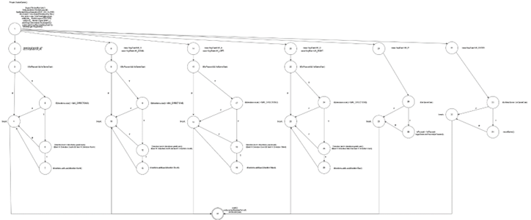

**startGame() Edge-pair coverage:**

TR = {[1, 2, 3], [1, 2, 8], [2, 3, 4], [2, 3, 5], [3, 4, 5], [3, 5, 2], [3, 5, 6], [4, 5, 2], [4, 5, 6], [5, 2, 8], [5, 2, 3], [5, 6, 2], [5, 6, 7], [6, 2, 8], [6, 2, 3], [6, 7, 2]}

Test paths = {[1, 2, 8], [1, 2, 3, 4, 5, 6, 7, 2, 8], [1, 2, 3, 4, 5, 2, 8], [1, 2, 3, 5, 2, 3, 4, 5, 2, 8], [1, 2, 3, 5, 6, 2, 3, 5, 6, 2, 8]}

CFG:

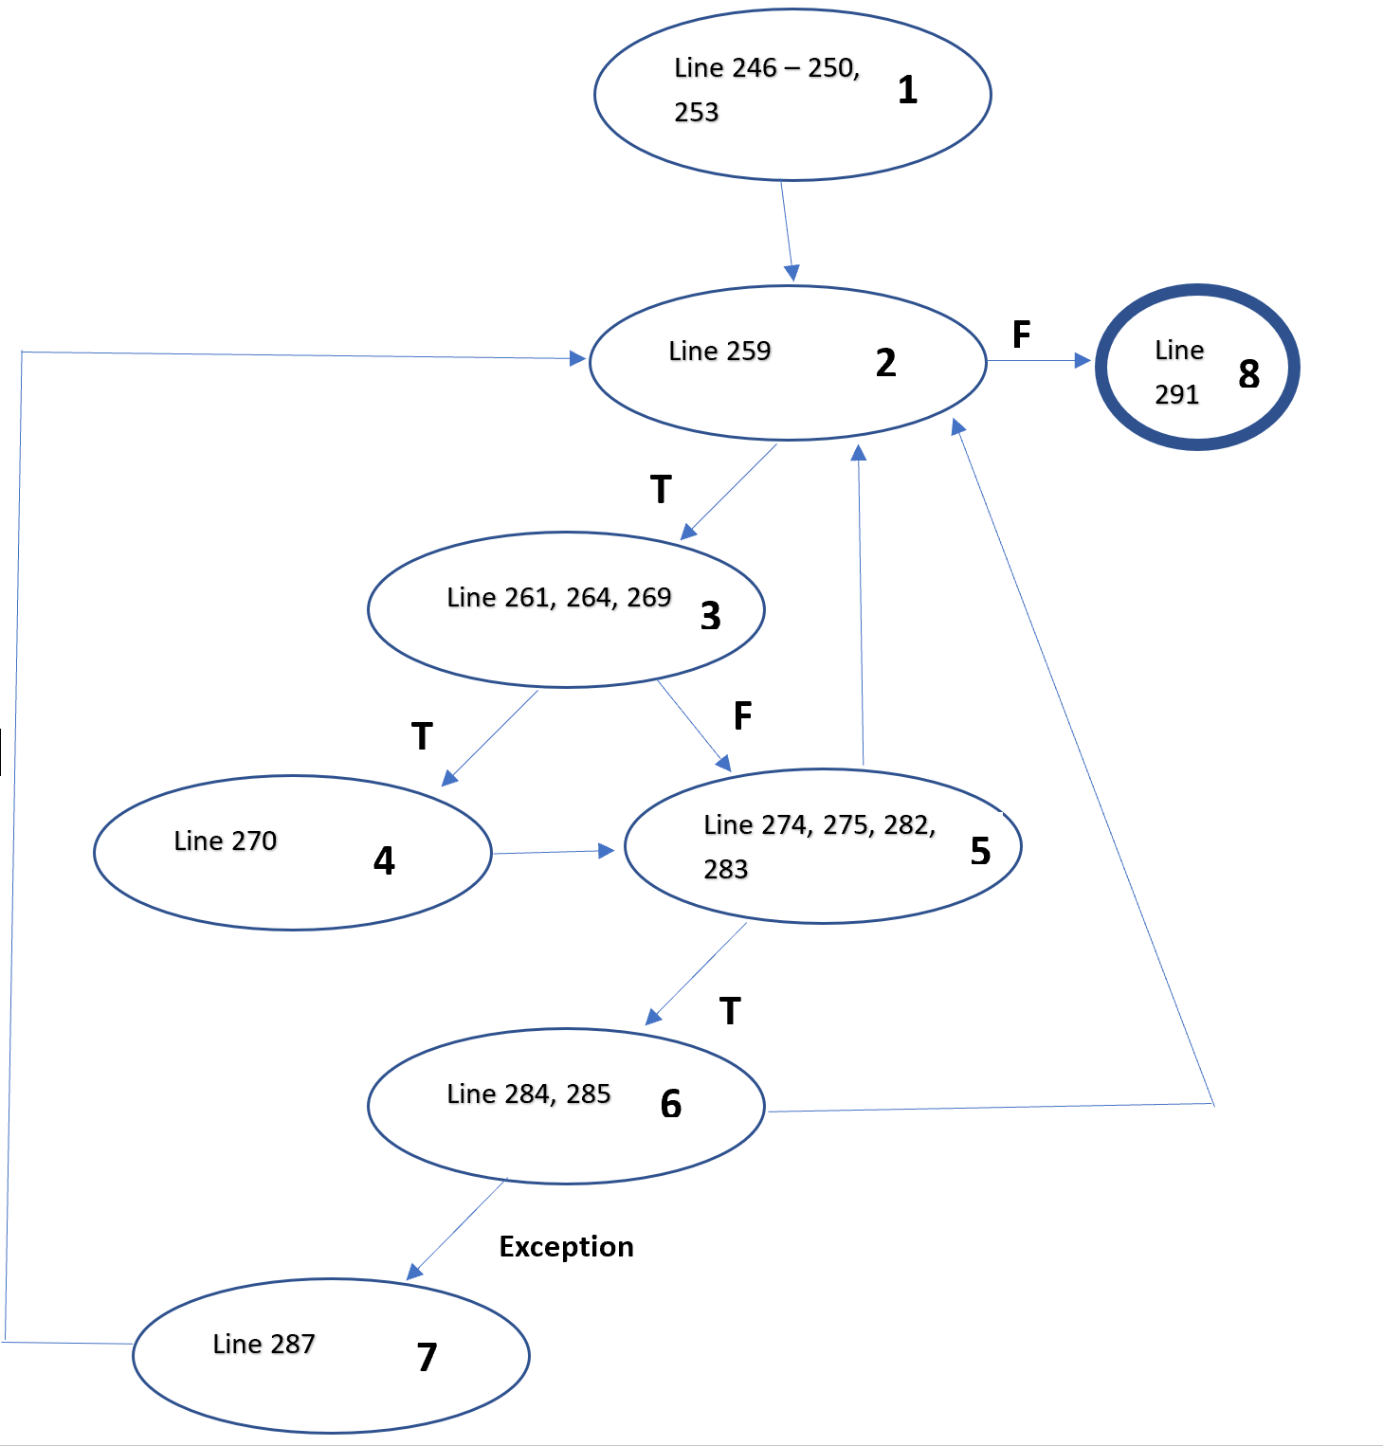

**updateSnake() Edge pair coverage:**

TR = {[1, 2, 3], [1, 4, 5], [1, 6, 7], [1, 8, 9], [2, 3, 10], [4, 5, 10], [6, 7, 10], [8, 9, 10], [3, 10, 11], [3, 10, 12], [5, 10, 11], [5, 10, 12], [7, 10, 11], [7, 10, 12], [9, 10, 11], [9, 10, 12], [10, 12, 13], [10, 12, 14], [12, 13, 14], [12, 14, 15], [12, 14, 17], [13, 14, 15], [13, 14, 17], [14, 15, 16], [14, 15, 17], [15, 16, 17]}

Test paths = {[1, 2, 3, 10, 12, 14, 17], [1, 2, 3, 10, 11], [1, 4, 5, 10, 11], [1, 6, 7, 10, 11], [1, 8, 9, 10, 11], [1, 4, 5, 10, 12, 13, 14, 17], [1, 6, 7, 10, 12, 13, 14, 15, 17], [1, 8, 9, 10, 12, 14, 15, 16, 17]}

CFG:

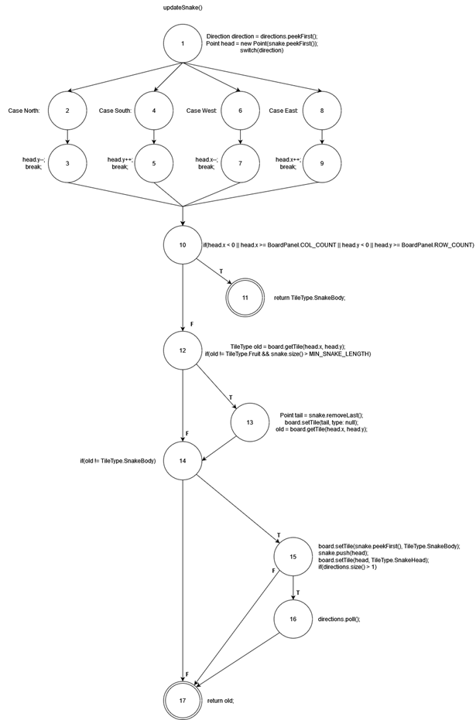

Testing Results and Code Coverage percentage:

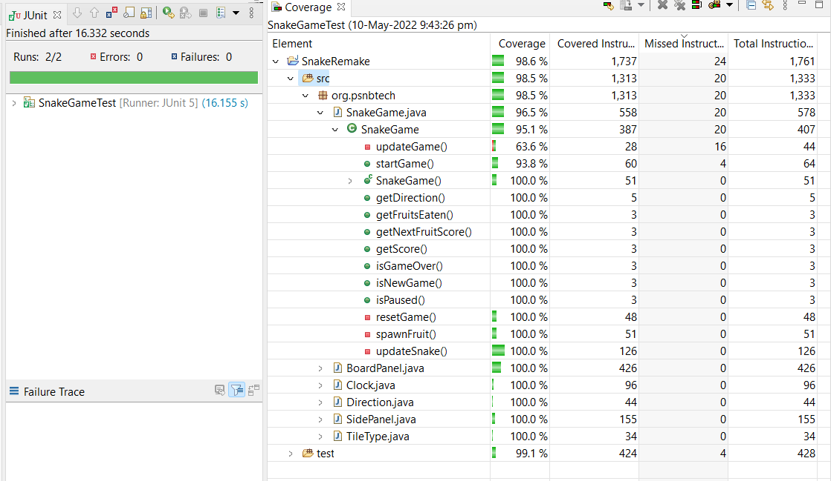

Lessons we learned and Reflection:

Reflecting upon this project, it’s safe to say that there was a lot we learned in working on this project. One lesson was time and workload management, we could’ve completed this project much more smoothly had we not started when we had. We were both relatively inexperienced in designing JUnit test cases which hindered our test design, but we were able to overcome much of that. Our overall thoughts about the software testing was that it was manageable yet nerve-wracking to see the code coverage score changing with changes to the code. Overall I think we’d both like to learn more about JUnit testing as well as test coverage criteria in the future to better understand and utilize it.

|  |  |
| --- | --- |
|  |  |
|  |  |